MUHAMMAD SHOAIB KHAN

B12101087

BSCS 3RD YEAR

SECTION A

Project report

HOTEL MANAGEMENT SYSTEM

NAME: MUHAMMAD SHOAIB KHAN

SEAT NUMBER: B12101087

CLASS: BSCS 3RD YEAR (MORNING)

SECTION: A

INTRODUCTION:

Introduction of Project: The objective of the project is to design Hotel Management application which enables the manager to keep the record of the hotel and the customers. The project has been designed in C#.NET technology and consists of a Oracle Database which acts as the database for the project. My motivation for the project came from my enthusiasm and strong urge to learn C# and .NET which is one of the fastest growing technologies in today’s world. The Hotel Management System project mainly consists of two types of users. The customers who access the information provided by the website and the administrator who modifies and updates the information. All the data needed for the application is stored in the form of tables in the Oracle Database 11g. The report contains the details of all the tasks carried out during the entire software.

Introduction of C#: **C#**(pronounced as *see sharp*) is a [multi-paradigm programming language](http://en.wikipedia.org/wiki/Multi-paradigm_programming_language) encompassing [strong typing](http://en.wikipedia.org/wiki/Strong_typing),[imperative](http://en.wikipedia.org/wiki/Imperative_programming), [declarative](http://en.wikipedia.org/wiki/Declarative_programming), [functional](http://en.wikipedia.org/wiki/Functional_programming), [generic](http://en.wikipedia.org/wiki/Generic_programming), [object-oriented](http://en.wikipedia.org/wiki/Object-oriented_programming)([class](http://en.wikipedia.org/wiki/Class_(computer_science))-based), and [component-oriented](http://en.wikipedia.org/wiki/Component-based_software_engineering) programming disciplines. It was developed by [Microsoft](http://en.wikipedia.org/wiki/Microsoft) within its [.NET](http://en.wikipedia.org/wiki/.NET_Framework) initiative and later approved as a standard by [Ecma](http://en.wikipedia.org/wiki/Ecma_International" \o "Ecma International) (ECMA-334) and [ISO](http://en.wikipedia.org/wiki/International_Organization_for_Standardization) (ISO/IEC 23270:2006). C# is one of the programming languages designed for the [Common Language Infrastructure](http://en.wikipedia.org/wiki/Common_Language_Infrastructure).

C# is intended to be a simple, modern, general-purpose, object-oriented programming language.[[8]](http://en.wikipedia.org/wiki/C_Sharp_%28programming_language%29#cite_note-ECMA-334-10) Its development team is led by [Anders Hejlsberg](http://en.wikipedia.org/wiki/Anders_Hejlsberg). The most recent version is C# 5.0, which was released on August 15, 2012.

Introduction of Oracle 11g:

**Oracle Database** (commonly referred to as **Oracle RDBMS** or simply as **Oracle**) is an [object-relational database management system](http://en.wikipedia.org/wiki/Object-relational_database_management_system) produced and marketed by [Oracle Corporation](http://en.wikipedia.org/wiki/Oracle_Corporation).

[Larry Ellison](http://en.wikipedia.org/wiki/Larry_Ellison) and two friends and former co-workers, [Bob Miner](http://en.wikipedia.org/wiki/Bob_Miner) and [Ed Oates](http://en.wikipedia.org/wiki/Ed_Oates), started a consultancy called Software Development Laboratories (SDL) in 1977. SDL developed the original version of the Oracle software. The name *Oracle* comes from the code-name of a [CIA](http://en.wikipedia.org/wiki/Central_Intelligence_Agency)-funded project Ellison had worked on while previously employed by [Ampex](http://en.wikipedia.org/wiki/Ampex" \o "Ampex).

Technology Used:  
1) Microsoft C#.Net

2) Oracle Database 11g

Minimum Hardware Requirements:

Intel Pentium® 4 System

1 GB RAM

32-MB Graphics Card

40 GB Hard Drive

Key Board

Mouse

Minimum Software Requirements:

Microsoft Windows XP Service Pack 2

Visual Studio 2010

Oracle 11g Database

Entity-Relationship Diagram of Project

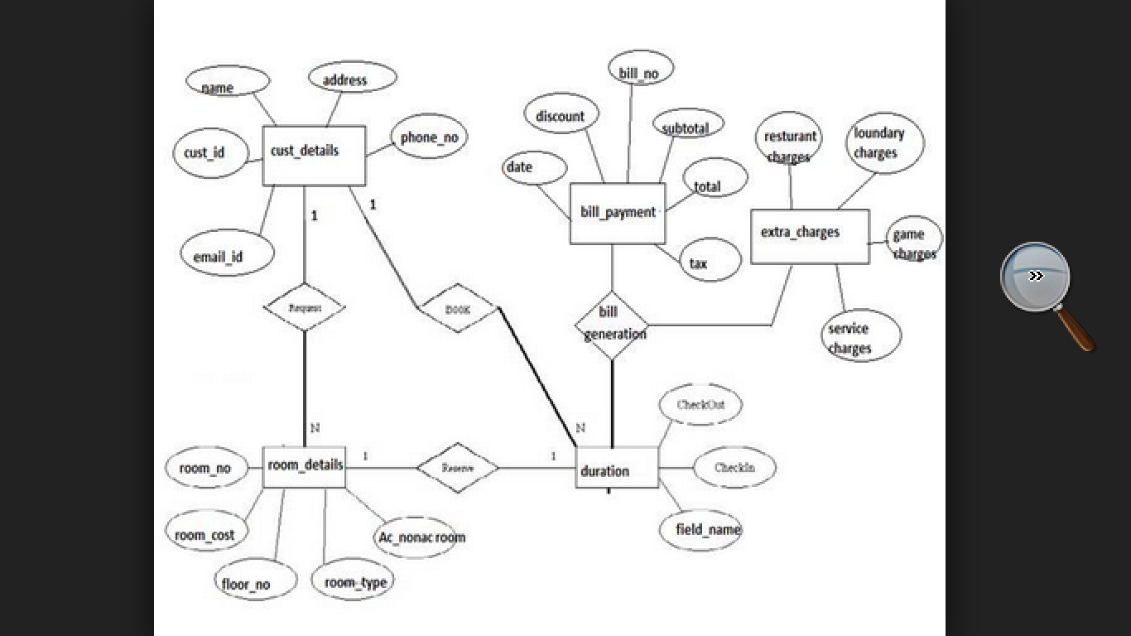

As, this Entity-Relationship Diagram explains that there are five tables used in this project which are 1) ROOM_DETAILS 2) DURATION 3) BILL_PAYMENT 4) EXTRA_CHARGES 5) CUST_DETAILS. These tables are connected to each other in some specific order showing how the tables are relates to each other.

These tables are attached with us using foreign keys which join these tables to one and another. These tables also contain their own primary keys which having the properties of not null and unique.

Project Overview:

1. Login Screen:

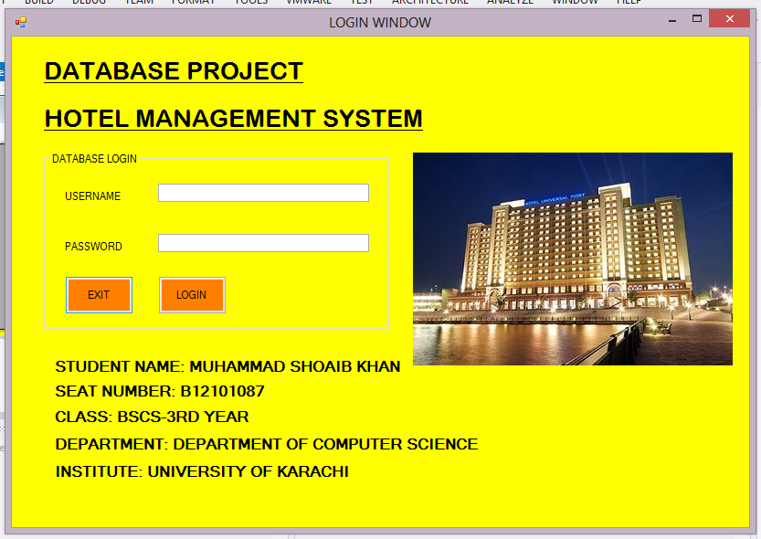

The first window of the project is the login screen which asks for username and password of the user to login to the project. Student information can also be view on the login screen.

1. Main Menu:

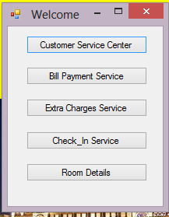

The second screen after the login is the main menu which shows the names of the tables used in the project in the shape of buttons. You can access the tables record by clicking one of these buttons.

1. Table Window:

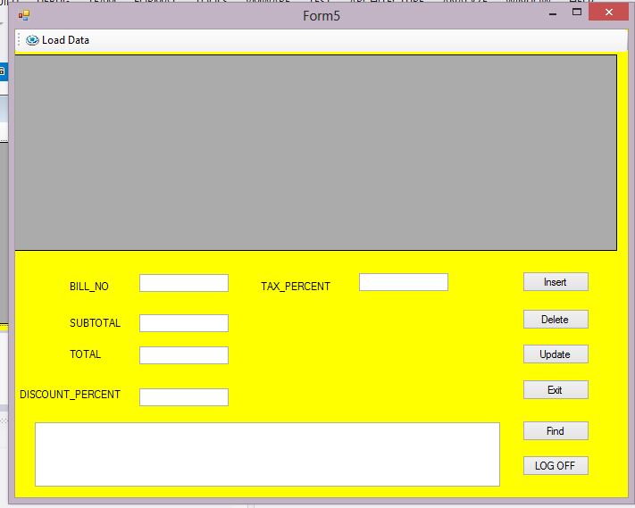

After click on one of the buttons on the main menu you will come to the table window showing in the picture above. On the top you can seed the load data button and on the form you can see the insert, delete, update, exit, find and logoff buttons. These are also text boxes present for inserting or manipulating data items in the database.

1. Load data in the window:

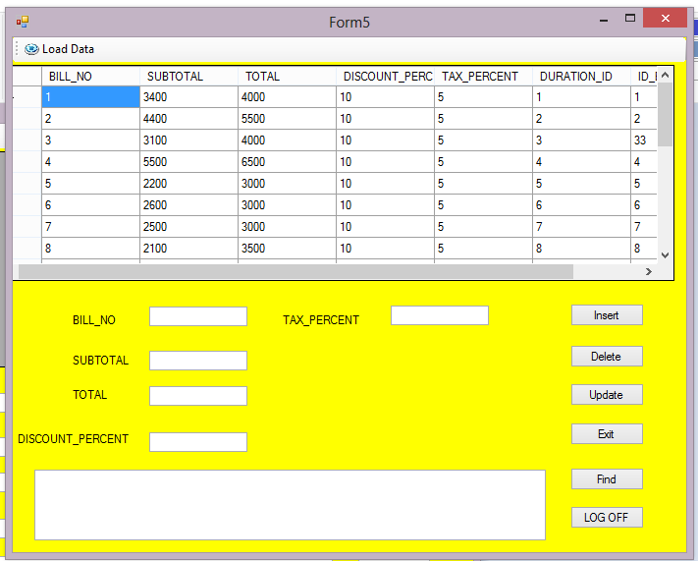

You can load data in the data grid view by pressing the load data button on the main menu. It will display the data of the windows form table.

Conclusion:

It is a simple database project for inserting, deleting, manipulating, retrieving, storing and viewing of the items of hotel management project present in this database project made for course name Database Management System of University of Karachi for fulfilling the course requriements.